Web Development 2 Assignment

C13569113 Andrew McCormack

PHP pages used

* autoReserve.php

1. Handles all database management matters relating to the reserving of books
2. searchByCategory.php posts ISBN number to this page when a user chooses to reserve a book from the list of returned results in their search. The ISBN is then used to edit the reserved column in the books table, where ISBN matches the row of reserved, changing its value from ‘N’ to ‘Y’. The posted ISBN number is also used to insert into the reservedBooks table, when adding the values of the ISBN, the name of the currently logged in user and the current date.
3. searchByAuthor.php posts ISBN number to this page when a user chooses to reserve a book from the list of returned results in their search. The ISBN is then used to edit the reserved column in the books table, where ISBN matches the row of reserved, changing its value from ‘N’ to ‘Y’. The posted ISBN number is also used to insert into the reservedBooks table, when adding the values of the ISBN, the name of the currently logged in user and the current date.
4. Reserve.php posts ISBN number to this page when a user chooses to reserve a book from the list of all books in the database, which are listed in reserve.php. The ISBN is then used to edit the reserved column in the books table, where ISBN matches the row of reserved, changing its value from ‘N’ to ‘Y’. The posted ISBN number is also used to insert into the reservedBooks table, when adding the values of the ISBN, the name of the currently logged in user and the current date.
5. If the page is successfully able to change and insert the values as needed, ‘Book Successfully Reserved’ will be displayed to the user, if there is a problem ‘There was an error when processing the request’ will be displayed.

* db_book.php
  1. This page opens a connection to the database, using the required credentials to login. It is included at the top of every other php file used in the database to simplify connection to the database throughout the website.
  2. If a connection cannot be opened, the die function will be run and an error report will be sent to the user.
* Index.php
  1. The home page of the website, when a user first try’s to access this page, if they are not logged in they will be automatically redirected to the login page. An unidentified user cannot access the main website in any way.
  2. Contains the nav bar allowing for access to other functions of the site
  3. The currently logged in user’s name will be displayed in white at the bottom of the page.
* Login.php
  1. A simple login page that prompts for a registered user’s username and password through a form. The user’s input is posted and passed into variables, where they are checked against username’s and matching passwords in the user’s table of the database. If a match is found they will be logged in as that user.
  2. When a user is logged in, a $_session variable is created for username, this session is checked for at the start of every other page in the website and persists throughout the use of the site allowing access to the main pages until the user chooses to logout by clicking logout.php from the nav bar
  3. The login form has error checking for all types of user input. If the user does not fill anything in, or only fills in one of the two fields, they will be told they must fill in all fields. If no match is found for the data they submit they will be told ‘Wrong username or password’
  4. Below the login form, a link to register is shown entitled, ‘Not registered an account?, click here’. This link will take them to register.php where they can register an account
* Logout.php
  1. When this page is clicked, the username session variable is deleted and destroyed effectively logging out the user. When the page detects that no user is logged in they are automatically returned to the login.php page.
* noReserved.php
  1. This page gets displayed when a user tries to access the viewReserved.php page when they have not reserved any books. viewReserved.php will automatically redirect them to this page where they will be given the message ‘You have not reserved any books!’
* register.php
  1. A registration page that contains a form with username, password, confirm password, firstname, surname, address1, address2, city, telephone and mobile fields.
  2. There are a number of error checks that must pass before data gets posted. All fields must be filled in, a user cannot have the same name as someone already in the database, the password and confirm password fields must match
  3. When a user fills in all of the above fields, If error checks validate, the information will be posted and added to the users table of the database.
  4. Upon successful registration to the database, the user will be redirected to login.php, allowing them to login with their newly created account.
* removeReserved.php
  1. This page is invoked when a user chooses to click the remove reservation button for a book they have reserved when on the viewReserved.php page. The ISBN of the chosen book gets passed in from viewReserved.php where it is used to edit the reserved column in the books table, where ISBN matches the row of reserved, changing its value from ‘Y’ to ‘N’. The posted ISBN number is also used to delete the row in the reservedBooks table containing the chosen ISBN number, thus allowing the book to be reserved by someone else.
* reserve.php
  1. Displays a table of all books in the library split up into columns of ‘ISBN’, ‘Title’, ‘Author’, ‘Edition’, ‘Year’, ‘Category’, ‘Reserved’ and finally a column which contains clickable reserve buttons for each row, allowing the user to reserve a book should they click it by passing the ISBN of the book into autoReserve.php. However if a book has already been reserved by another user, the reserve button will be greyed out to indicate it cannot be reserved.
  2. The page limits the amount of data per page to five rows, numbered links above the table allow the user to check further data.
* searchByCategory.php
  1. This page allows the user to search the database for books with the same category description. A form is displayed into which the user can insert there searchterm.
  2. Error checking is used on the page. If the user enters nothing into the search box and clicks submit, they will be told ‘You must fill in the category box!’. If the search returns no results, ‘No results found, please refine search!’ will be displayed.
  3. When a search is successful the data is displayed in a table of all books in the library split up into columns of ‘ISBN’, ‘Title’, ‘Author’, ‘Edition’, ‘Year’, ‘Category’, ‘Reserved’ and finally a column which contains clickable reserve buttons for each row, allowing the user to reserve a book should they click it by passing the ISBN of the book into autoReserve.php. However if a book has already been reserved by another user, the reserve button will be greyed out to indicate it cannot be reserved.
  4. The page limits the amount of data per page to five rows, numbered links above the table allow the user to check further data.
* searchByTitle&Author.php
  1. This page allows the user to search the database for books with the same title, authors with the same name or both. A form is displayed into which the user can insert there searchterm(s).
  2. Error checking is used on the page. If the user enters nothing into either of the search boxes and clicks submit, they will be told ‘You must fill in the at least one of the boxes!’. If the search returns no results, ‘No results found, please refine search!’ will be displayed.
  3. When a search is successful the data is displayed in a table of all books in the library split up into columns of ‘ISBN’, ‘Title’, ‘Author’, ‘Edition’, ‘Year’, ‘Category’, ‘Reserved’ and finally a column which contains clickable reserve buttons for each row, allowing the user to reserve a book should they click it by passing the ISBN of the book into autoReserve.php. However if a book has already been reserved by another user, the reserve button will be greyed out to indicate it cannot be reserved.
  4. The page limits the amount of data per page to five rows, numbered links above the table allow the user to check further data.
* viewReserved.php
  1. This page allows a user to view any books they have currently reserved. If no books are reserved they will be redirected to noReserved.php
  2. The books the user has currently reserved is displayed in a table containing the columns ‘ISBN’, ‘Title’, ‘Author’, ‘Edition’, ‘Year’, ‘Category’, ‘Date Reserved’ and finally a column which contains clickable remove buttons for each row, allowing the user to remove a reserved book should they click it by passing the ISBN of the book into removeReserve.php.

Login.php

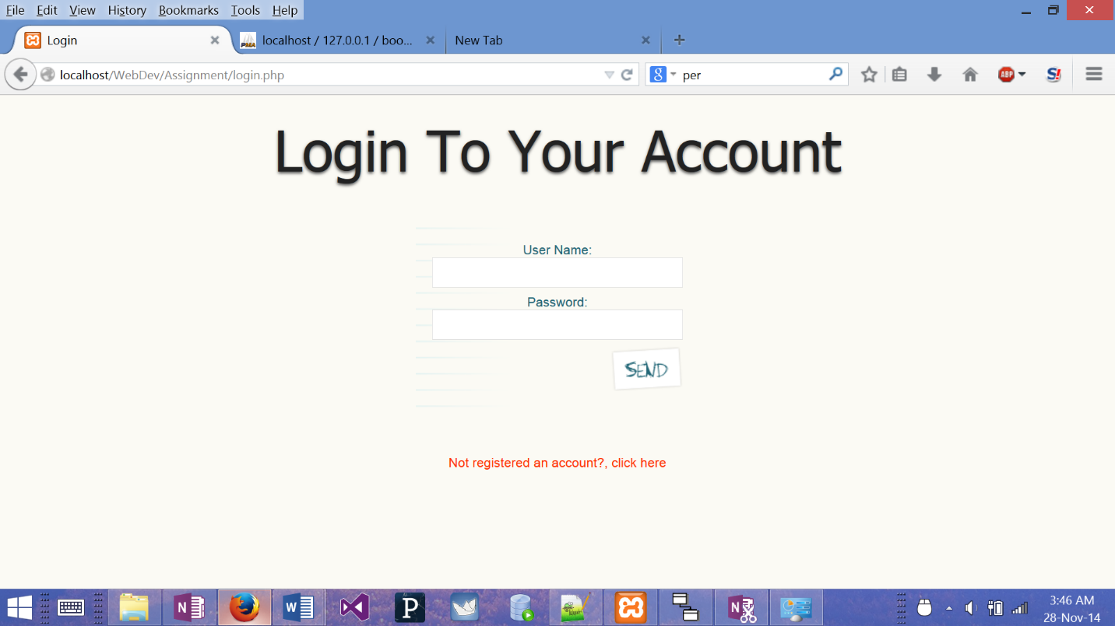

Register.php

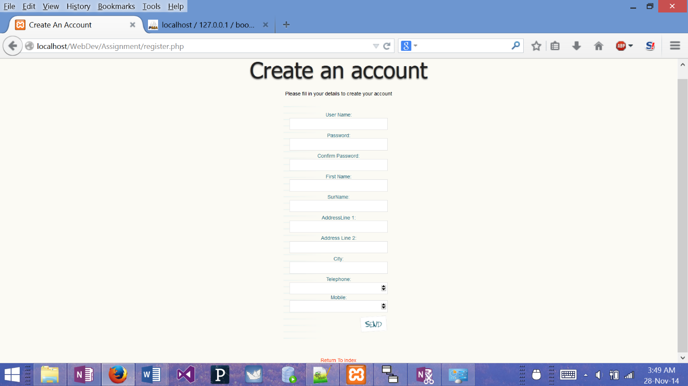

Index.php

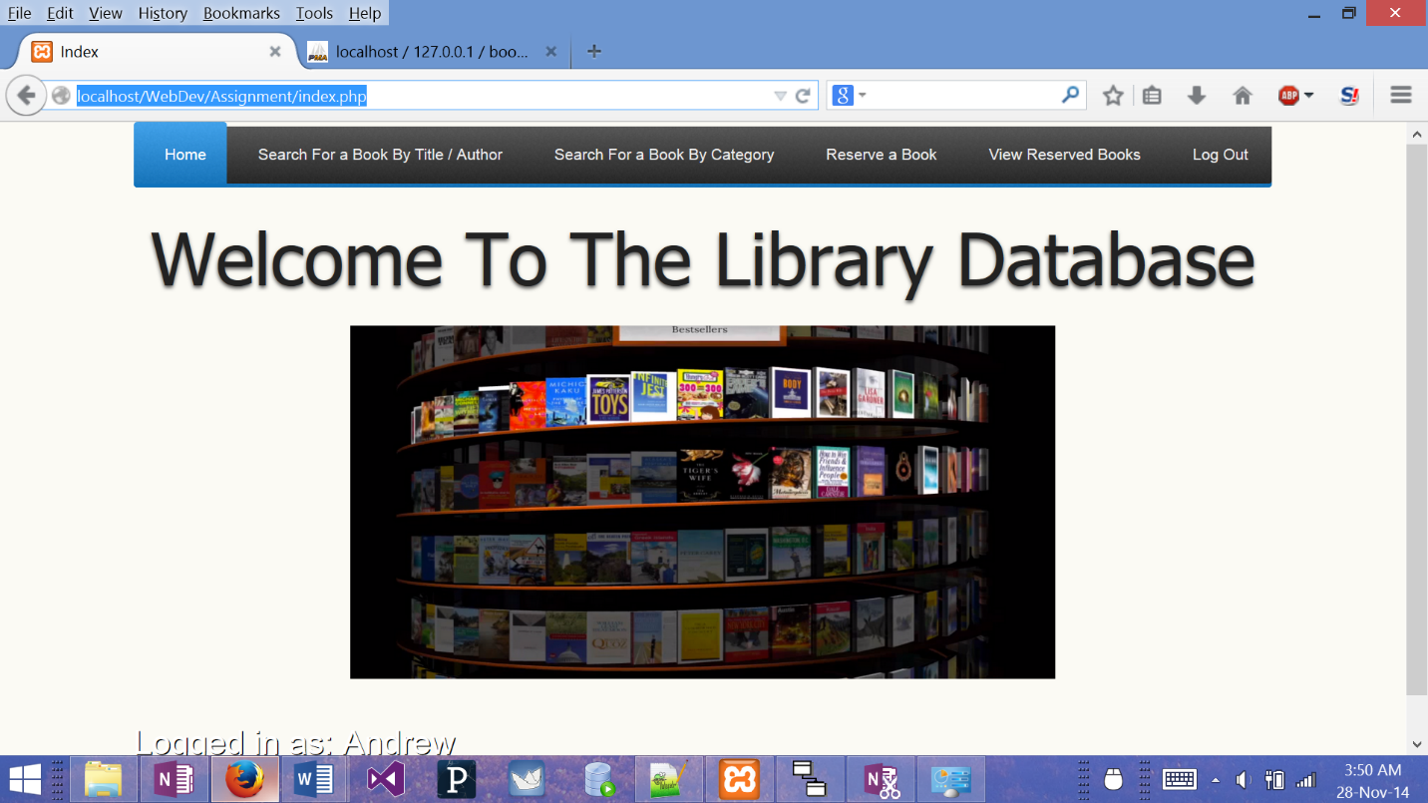

searchByTitle&Author.php

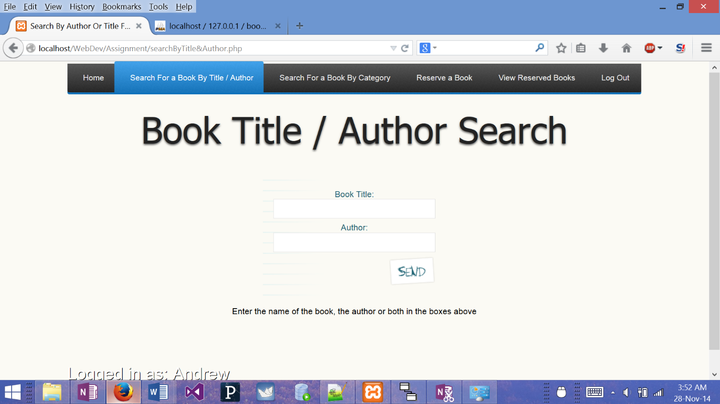

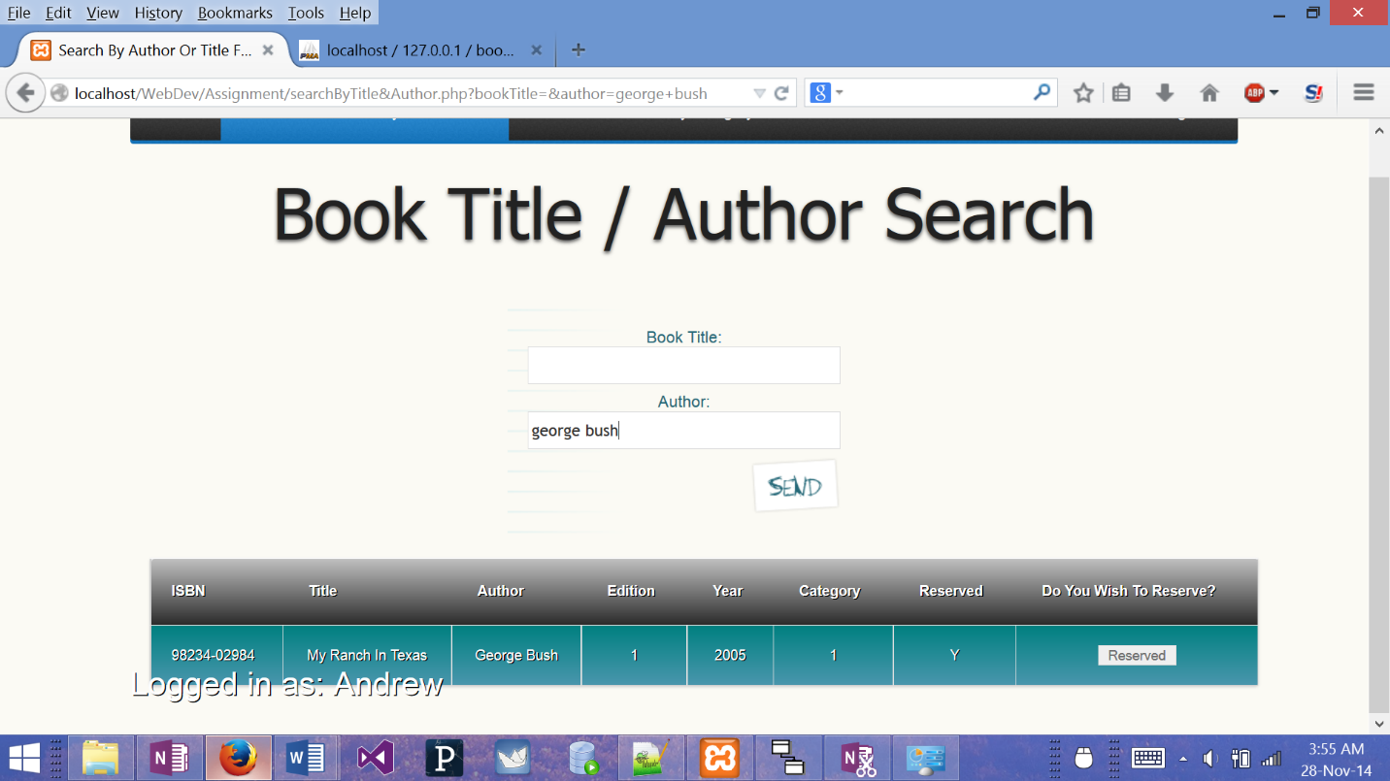

searchByCategory.php

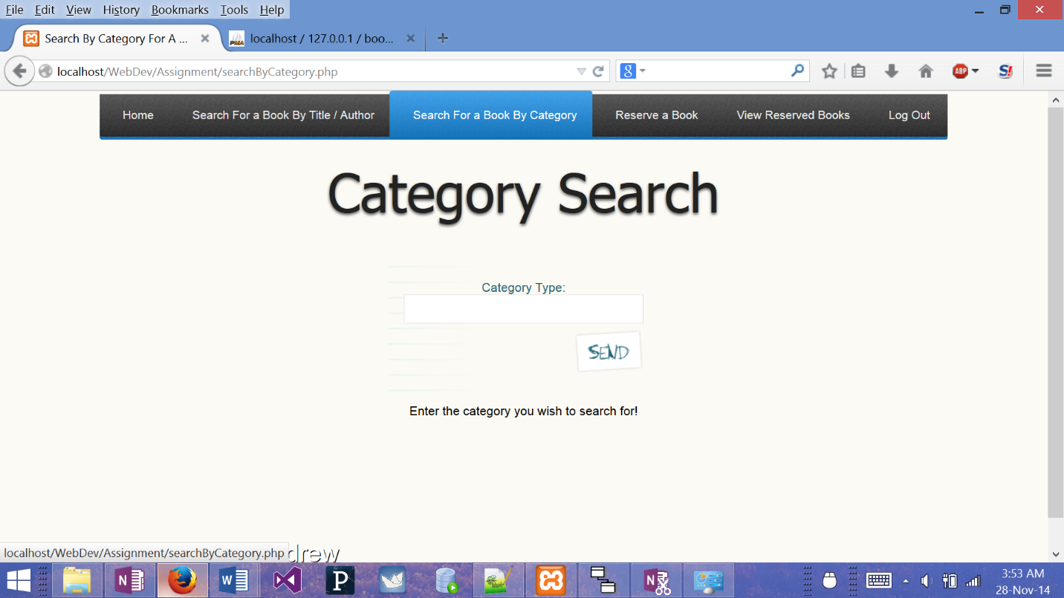

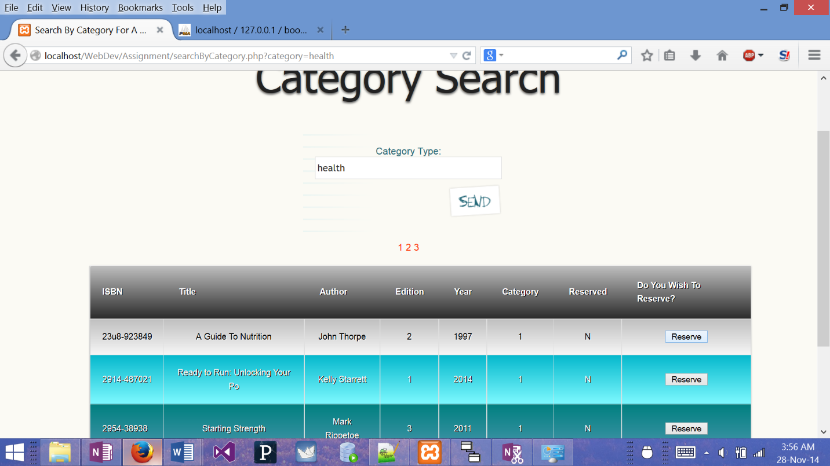

Reserve.php

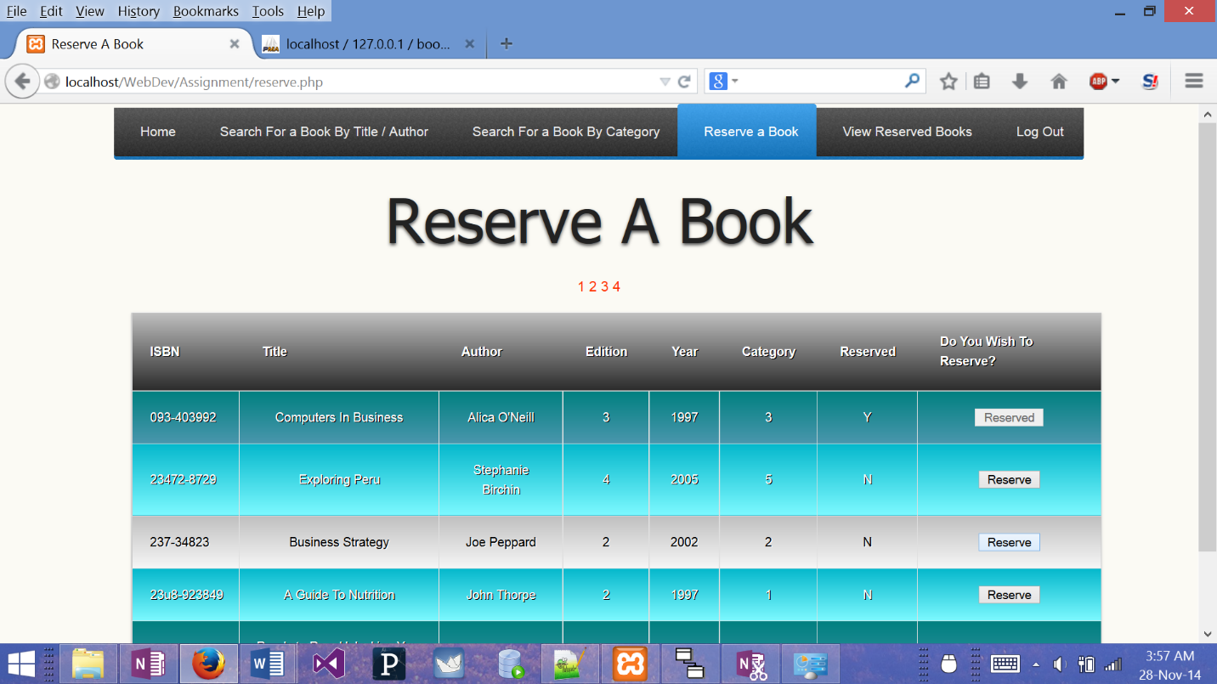

viewReserved.php

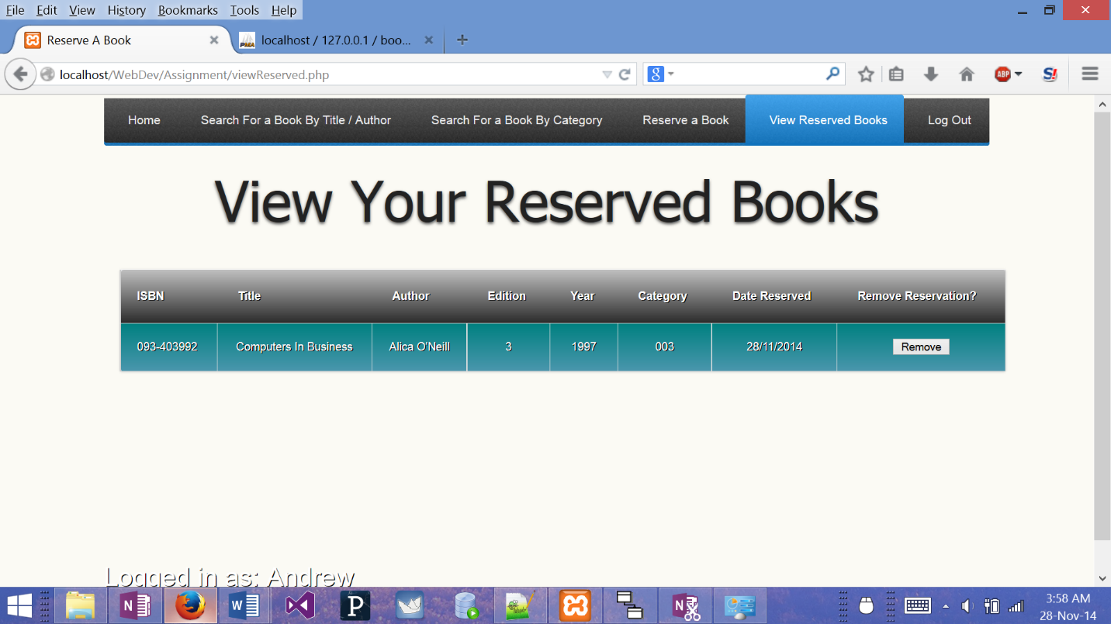

autoReserve.php

<!DOCTYPE html PUBLIC "-//W3C//DD XHTML 1.0 Transitional//EN" "http://www.w3.org/TR/xhtml1/DTD/xhtml1-transitional.dtd">

<html xmlns="http://www.w3.org/1999/xhtml">

<html lang="en">

<head>

<meta charset='utf-8'>

<meta http-equiv="X-UA-Compatible" content="IE=edge">

<meta name="viewport" content="width=device-width, initial-scale=1">

<link rel="stylesheet" href="style.css">

<script src="http://code.jquery.com/jquery-latest.min.js" type="text/javascript"></script>

<script src="script.js"></script>

<title>Reserving Book</title>

<?php

session_start();

if(!$_SESSION['userName'])

{

header("location:login.php");

}

?>

</head>

<body>

<div class="wrapper">

<div id='cssmenu'>

<ul>

<li><a href="index.php"><span>Home</span></a></li>

<li><a href="searchByTitle&Author.php"><span>Search For a Book By Title / Author</span></a></li>

<li><a href="searchByCategory.php"><span>Search For a Book By Category</span></a></li>

<li class='active'><a href="reserve.php"><span>Reserve a Book</span></a></li>

<li><a href="viewReserved.php"><span>View Reserved Books</span></a></li>

<li class='last'><a href="logout.php"><span>Log Out</span></a></li>

</ul>

</div>

<center>

<?php

require_once "db_book.php";

$reserveId = $_POST["reserveId"];

$sql1="UPDATE `book`.`books` SET `reserved` = 'Y' WHERE `books`.`ISBN` = " . "'" . $reserveId . "'";

$sql2="INSERT INTO `book`.`reservedbooks` (`ISBN`, `userName`, `reservedDate`) VALUES ('". $reserveId."','".$_SESSION['userName']."','".date("d/m/Y")."')";

if (!mysql_query($sql1) || !mysql_query($sql2))

{

echo $sql1;

echo "<h1>There was an error when processing the request</h1>";

}

else

{

$result = mysql_query($sql1);

$result = mysql_query($sql2);

echo "<h1>Book Successfully Reserved</h1>";

}

?>

<a href="index.php">Return to index</a>

</center>

</div>

</div>

<?php

echo "<div class=\"footer\">";

echo "<p>Logged in as: " . $_SESSION['userName'] . "</p>";

echo "</div>";

?>

<script src="http://code.jquery.com/jquery-latest.min.js" type="text/javascript"></script>

<script src="script.js"></script>

</body>

</html>

Db_Book.php

<?php

$db = mysql_connect('localhost', 'root', '');

if ( $db === FALSE ) die('Fail message');

if ( mysql_select_db("book") === FALSE ) die("Fail message");

?>

Index.php

<!DOCTYPE html>

<html lang="en">

<head>

<meta charset='utf-8'>

<meta http-equiv="X-UA-Compatible" content="IE=edge">

<meta name="viewport" content="width=device-width, initial-scale=1">

<link rel="stylesheet" href="style.css">

<title>Index</title>

<?php

session_start();

if(!$_SESSION['userName'])

{

header("location:login.php");

}

?>

</head>

<body>

<div class="wrapper">

<div id='cssmenu'>

<ul>

<li class='active'><a href="index.php"><span>Home</span></a></li>

<li><a href="searchByTitle&Author.php"><span>Search For a Book By Title / Author</span></a></li>

<li><a href="searchByCategory.php"><span>Search For a Book By Category</span></a></li>

<li><a href="reserve.php"><span>Reserve a Book</span></a></li>

<li><a href="viewReserved.php"><span>View Reserved Books</span></a></li>

<li class='last'><a href="logout.php"><span>Log Out</span></a></li>

</ul>

</div>

<center>

<h1>Welcome To The Library Database</h1>

<img src="./images/google-digital-library.png" alt="library" style="width:680px;height:340px">

</center></div>

</div>

<?php

echo "<div class=\"footer\">";

echo "<p>Logged in as: " . $_SESSION['userName'] . "</p>";

echo "</div>";

?>

<script src="http://code.jquery.com/jquery-latest.min.js" type="text/javascript"></script>

<script src="script.js"></script>

</body>

</html>

Login.php

<!DOCTYPE html PUBLIC "-//W3C//DD XHTML 1.0 Transitional//EN" "http://www.w3.org/TR/xhtml1/DTD/xhtml1-transitional.dtd">

<html xmlns="http://www.w3.org/1999/xhtml">

<html lang="en">

<head>

<meta charset='utf-8'>

<meta http-equiv="X-UA-Compatible" content="IE=edge">

<meta name="viewport" content="width=device-width, initial-scale=1">

<link rel="stylesheet" href="style.css">

<script src="http://code.jquery.com/jquery-latest.min.js" type="text/javascript"></script>

<script src="script.js"></script>

<title>Login</title>

<?php

session_start();

?>

</head>

<body>

<center>

<h1>Login To Your Account</h1>

<?php

require_once "db_book.php";

echo "<form id=\"form4\" method=\"post\">";

echo "<fieldset><legend>Contact form</legend><p class=\"first\">";

echo "<p class=\"first\">";

echo "<label for=\"userName\">User Name:</label>";

echo "<input type=\"text\" name=\"userName\" maxlength=\"21\" size=\"30\">";

echo "</p>";

echo "<p>";

echo "<label for=\"password\">Password:</label>";

echo "<input type=\"password\" name=\"password\" maxlength=\"6\" size=\"30\">";

echo "</p>";

echo "<p>";

echo "<p class=\"submit\"><button type=\"submit\">Submit</button></p>";

echo "</fieldset>";

echo "</form>";

echo "</tbody>";

$result = mysql_query("SELECT * FROM users");

if ( isset($_POST['userName']) && isset($_POST['password']))

{

$u = mysql_real_escape_string( $_POST['userName']);

$p = mysql_real_escape_string( $_POST['password']);

// To protect MySQL injection

$u = stripslashes($u);

$u = stripslashes($u);

$u = mysql_real_escape_string($u);

$p = mysql_real_escape_string($p);

$sql="SELECT * FROM users WHERE userName ='$u' and password ='$p'";

$result=mysql_query($sql);

// Mysql_num_row is counting table row

$count=mysql_num_rows($result);

// If result matched $u and $p, table row must be 1 row

if($count==1)

{

// Register $myusername, $mypassword and redirect to file "index.php"

$_SESSION['userName'] = $u;

$_SESSION['password'] = $p;

header("location:index.php");

}

else

{

echo "Wrong Username or Password";

}

}

ob_end_flush();

?>

<br>

<br>

<a href="register.php">Not registered an account?, click here</a>

</center>

</body>

</html>

Logout.php

<!DOCTYPE html PUBLIC "-//W3C//DD XHTML 1.0 Transitional//EN" "http://www.w3.org/TR/xhtml1/DTD/xhtml1-transitional.dtd">

<html xmlns="http://www.w3.org/1999/xhtml">

<html lang="en">

<head>

<meta charset='utf-8'>

<meta http-equiv="X-UA-Compatible" content="IE=edge">

<meta name="viewport" content="width=device-width, initial-scale=1">

<link rel="stylesheet" href="style.css">

<script src="http://code.jquery.com/jquery-latest.min.js" type="text/javascript"></script>

<script src="script.js"></script>

<title>LogOut</title>

</head>

<body>

<?php

session_start();

session_destroy();

header("location:index.php");

?>

<script src="http://code.jquery.com/jquery-latest.min.js" type="text/javascript"></script>

<script src="script.js"></script>

</body>

</html>

noReserved.php

<!DOCTYPE html PUBLIC "-//W3C//DD XHTML 1.0 Transitional//EN" "http://www.w3.org/TR/xhtml1/DTD/xhtml1-transitional.dtd">

<html xmlns="http://www.w3.org/1999/xhtml">

<html lang="en">

<head>

<meta charset='utf-8'>

<meta http-equiv="X-UA-Compatible" content="IE=edge">

<meta name="viewport" content="width=device-width, initial-scale=1">

<link rel="stylesheet" href="style.css">

<script src="http://code.jquery.com/jquery-latest.min.js" type="text/javascript"></script>

<script src="script.js"></script>

<?php

session_start();

if(!$_SESSION['userName'])

{

header("location:login.php");

}

?>

</head>

<body>

<div class="wrapper">

<div id='cssmenu'>

<ul>

<li><a href="index.php"><span>Home</span></a></li>

<li><a href="searchByTitle&Author.php"><span>Search For a Book By Title / Author</span></a></li>

<li><a href="searchByCategory.php"><span>Search For a Book By Category</span></a></li>

<li><a href="reserve.php"><span>Reserve a Book</span></a></li>

<li class='active'><a href="viewReserved.php"><span>View Reserved Books</span></a></li>

<li class='last'><a href="logout.php"><span>Log Out</span></a></li>

</ul>

</div>

<center>

<h1>No Reserved Books</h1>

<?php

require_once "db_book.php";

?>

<p>You have not reserved any books!</p>

</center>

</div>

</div>

<?php

echo "<div class=\"footer\">";

echo "<p>Logged in as: " . $_SESSION['userName'] . "</p>";

echo "</div>";

?>

</body>

</html>

Register.php

<!DOCTYPE html PUBLIC "-//W3C//DD XHTML 1.0 Transitional//EN" "http://www.w3.org/TR/xhtml1/DTD/xhtml1-transitional.dtd">

<html xmlns="http://www.w3.org/1999/xhtml">

<html lang="en">

<head>

<meta charset='utf-8'>

<meta http-equiv="imagetoolbar" content="no" />

<meta name="viewport" content="width=device-width, initial-scale=1">

<link rel="stylesheet" href="style.css">

<script src="http://code.jquery.com/jquery-latest.min.js" type="text/javascript"></script>

<script src="script.js"></script>

<title>Create An Account</title>

</head>

<body>

<center>

<h1>Create an account</h1>

<?php

require_once "db_book.php";

$result = mysql_query("SELECT * FROM users");

if ( isset($_POST['userName']) && isset($_POST['password']) && isset($_POST['firstName']) && isset($_POST['surName']) && isset($_POST['addressLine1']) && isset($_POST['addressLine2']) && isset($_POST['city']) && isset($_POST['telephone']) && isset($_POST['mobile']))

{

$check = True;

$u = trim(mysql_real_escape_string( $_POST['userName']));

$p = trim(mysql_real_escape_string( $_POST['password']));

$pc = trim(mysql_real_escape_string( $_POST['passwordConfirm']));

$n = trim(mysql_real_escape_string( $_POST['firstName']));

$sn = trim(mysql_real_escape_string( $_POST['surName']));

$a1 = trim(mysql_real_escape_string( $_POST['addressLine1']));

$a2 = trim(mysql_real_escape_string( $_POST['addressLine2']));

$c = trim(mysql_real_escape_string( $_POST['city']));

$t = trim(mysql_real_escape_string( $_POST['telephone']));

$m = trim(mysql_real_escape_string( $_POST['mobile']));

if ($p === $pc)

{

while ( $row = mysql_fetch_row($result) )

{

if ($row[0] == $u)

{

$check = False;

echo "That User Name has been taken, please use another User Name";

}

else if ($u == '' || $p == '' || $n == '' || $sn == '' || $a1 == '' || $a2 == '' || $c == '' || $t == '' || $m == '')

{

$check = False;

echo "Please fill in all fields!";

break;

}

}

if ($check == true)

{

$sql = "INSERT INTO `book`.`users` (`userName`, `password`, `firstName`, `surName`, `addressLine1`, `addressLine2`, `city`, `telephone`, `mobile`)

VALUES ('$u', '$p', '$n', '$sn', '$a1', '$a2', '$c', '$t', '$m')";

mysql_query($sql);

echo "Successfully added user: " . $u;

header("location:index.php");

}

}

else

{

echo "The passwords you entered do not match";

}

}

else

{

echo "Please fill in your details to create your account";

}

?>

<?php

echo "<form id=\"form4\" method=\"post\">";

echo "<fieldset><legend>Contact form</legend><p class=\"first\">";

echo "<p class=\"first\">";

echo "<label for=\"userName\">User Name:</label>";

echo "<input type=\"text\" name=\"userName\" id=\"userName\" maxlength=\"21\" size=\"30\">";

echo "</p>";

echo "<p>";

echo "<label for=\"password\">Password:</label>";

echo "<input type=\"password\" name=\"password\" id=\"password\" maxlength=\"6\" size=\"30\">";

echo "</p>";

echo "<p>";

echo "<label for=\"passwordConfirm\">Confirm Password:</label>";

echo "<input type=\"password\" name=\"passwordConfirm\" id=\"passwordConfirm\" maxlength=\"6\" size=\"30\">";

echo "</p>";

echo "<p>";

echo "<label for=\"firstName\">First Name:</label>";

echo "<input type=\"text\" name=\"firstName\" id=\"firstName\" maxlength=\"11\" size=\"30\">";

echo "</p>";

echo "<p>";

echo "<label for=\"surName:\">SurName:</label>";

echo "<input type=\"text\" name=\"surName\" id=\"surName\" maxlength=\"21\" size=\"30\">";

echo "</p>";

echo "<p>";

echo "<label for=\"addressLine1\">AddressLine 1:</label>";

echo "<input type=\"text\" name=\"addressLine1\" id=\"addressLine1\" maxlength=\"21\" size=\"30\">";

echo "</p>";

echo "<p>";

echo "<label for=\"addressLine2\">Address Line 2:</label>";

echo "<input type=\"text\" name=\"addressLine2\" id=\"addressLine2\" maxlength=\"21\" size=\"30\">";

echo "</p>";

echo "<p>";

echo "<label for=\"city\">City:</label>";

echo "<input type=\"text\" name=\"city\" id=\"city\" maxlength=\"11\" size=\"30\">";

echo "</p>";

echo "<p>";

echo "<label for=\"telephone\">Telephone:</label>";

echo "<input type=\"number\" name=\"telephone\" id=\"telephone\" maxlength=\"10\" size=\"30\">";

echo "<label for=\"mobile\">Mobile:</label>";

echo "<input type=\"number\" name=\"mobile\" id=\"number\" maxlength=\"10\ size=\"30\">";

echo "</p>";

echo "<p>";

echo "<p class=\"submit\"><button type=\"submit\">Add New</button></p>";

echo "</fieldset>";

echo "</form>";

?>

<br>

<br>

<a href="index.php">Return To Index</a>

</center>

<script src="http://www.google-analytics.com/urchin.js" type="text/javascript">

</script>

<script src="http://code.jquery.com/jquery-latest.min.js" type="text/javascript"></script>

<script src="script.js"></script>

<script type="text/javascript">

_uacct = "UA-783567-1";

urchinTracker();

</script>

</body>

</html>

removeReserve.php

<!DOCTYPE html PUBLIC "-//W3C//DD XHTML 1.0 Transitional//EN" "http://www.w3.org/TR/xhtml1/DTD/xhtml1-transitional.dtd">

<html xmlns="http://www.w3.org/1999/xhtml">

<html lang="en">

<head>

<meta charset='utf-8'>

<meta http-equiv="X-UA-Compatible" content="IE=edge">

<meta name="viewport" content="width=device-width, initial-scale=1">

<link rel="stylesheet" href="style.css">

<script src="http://code.jquery.com/jquery-latest.min.js" type="text/javascript"></script>

<script src="script.js"></script>

<title>Remove Reserved Books</title>

<?php

session_start();

if(!$_SESSION['userName'])

{

header("location:login.php");

}

?>

</head>

<body>

<div class="wrapper">

<div id='cssmenu'>

<ul>

<li><a href="index.php"><span>Home</span></a></li>

<li><a href="searchByTitle&Author.php"><span>Search For a Book By Title / Author</span></a></li>

<li><a href="searchByCategory.php"><span>Search For a Book By Category</span></a></li>

<li><a href="reserve.php"><span>Reserve a Book</span></a></li>

<li class='active'><a href="viewReserved.php"><span>View Reserved Books</span></a></li>

<li class='last'><a href="logout.php"><span>Log Out</span></a></li>

</ul>

</div>

<center>

<?php

require_once "db_book.php";

$reserveId = $_POST["reserveId"];

$u = $_SESSION['userName'];

$sql1="UPDATE `book`.`books` SET `reserved` = 'N' WHERE `books`.`ISBN` = '". $reserveId."'";

$sql2="DELETE FROM `book`.`reservedbooks` WHERE `reservedbooks`.`ISBN` ='" . $reserveId ."' AND `reservedbooks`.`userName` ='$u'";

if (!mysql_query($sql1) || !mysql_query($sql2))

{

echo "<h1>There was an error when processing the request</h1>";

}

else

{

$result = mysql_query($sql1);

$result = mysql_query($sql2);

echo "<h1>Book Successfully Removed!</h1>";

echo "<a href=\"viewReserved.php\">Remove another reservation?</a>";

}

?>

</div>

</div>

<?php

echo "<div class=\"footer\">";

echo "<p>Logged in as: " . $_SESSION['userName'] . "</p>";

echo "</div>";

?>

</center>

</body>

</html>

Reserve.php

<!DOCTYPE html PUBLIC "-//W3C//DD XHTML 1.0 Transitional//EN" "http://www.w3.org/TR/xhtml1/DTD/xhtml1-transitional.dtd">

<html xmlns="http://www.w3.org/1999/xhtml">

<html lang="en">

<head>

<meta charset='utf-8'>

<meta http-equiv="X-UA-Compatible" content="IE=edge">

<meta name="viewport" content="width=device-width, initial-scale=1">

<link rel="stylesheet" href="style.css">

<script src="http://code.jquery.com/jquery-latest.min.js" type="text/javascript"></script>

<script src="script.js"></script>

<title>Reserve A Book</title>

<?php

session_start();

if(!$_SESSION['userName'])

{

header("location:login.php");

}

?>

</head>

<body>

<div class="wrapper">

<div id='cssmenu'>

<ul>

<li><a href="index.php"><span>Home</span></a></li>

<li><a href="searchByTitle&Author.php"><span>Search For a Book By Title / Author</span></a></li>

<li><a href="searchByCategory.php"><span>Search For a Book By Category</span></a></li>

<li class='active'><a href="reserve.php"><span>Reserve a Book</span></a></li>

<li><a href="viewReserved.php"><span>View Reserved Books</span></a></li>

<li class='last'><a href="logout.php"><span>Log Out</span></a></li>

</ul>

</div>

<center>

<h1>Reserve A Book</h1>

<?php

require_once "db_book.php";

$sql = (" SELECT * FROM books LEFT JOIN categories ON books.category = categories.categoryID");

$result = mysql_query($sql);

$row = mysql_fetch_assoc($result);

// number of results to show per page

$per_page = 5;

// figure out the total pages in the database

$total_results = mysql_num_rows($result);

$total_pages = ceil($total_results / $per_page);

// check if the 'page' variable is set in the URL

if (isset($_GET['page']) && is_numeric($_GET['page']))

{

$show_page = $_GET['page'];

// make sure the $show_page value is valid

if ($show_page > 0 && $show_page <= $total_pages)

{

$start = ($show_page -1) * $per_page;

$end = $start + $per_page;

}

else

{

// error - show first set of results

$start = 0;

$end = $per_page;

}

}

else

{

// if page isn't set, show first set of results

$start = 0;

$end = $per_page;

}

// display pagination

for ($i = 1; $i <= $total_pages; $i++)

{

echo "<a href='reserve.php?page=$i'>$i</a> ";

}

echo "</p>";

echo "<table cellspacing='0'>";

echo "<thead>";

echo "<form action= \"autoReserve.php\" method='post'>";

echo"<tr><th>"; echo "ISBN";

echo"</th><th>"; echo "Title";

echo"</th><th>"; echo "Author";

echo "</th><th>"; echo "Edition";

echo "</th><th>"; echo "Year";

echo "</th><th>"; echo "Category";

echo "</th><th>"; echo "Reserved";

echo "</th><th>"; echo "Do You Wish To Reserve?";

echo "</th></tr>";

echo"</thead>";

echo"<tbody>";

// loop through results of database query, displaying them in the table

for ($i = $start; $i < $end; $i++)

{

// make sure that PHP doesn't try to show results that don't exist

if ($i == $total_results)

{

break;

}

if (($i % 2) == 0)

{

echo"<tr class =\"even\"><td>";

}

else

{

echo"<tr><td>";

}

$ISBN = mysql_result($result, $i, 'ISBN');

$bookTitle = mysql_result($result, $i, 'bookTitle');

$author = mysql_result($result, $i, 'author');

$edition = mysql_result($result, $i, 'edition');

$year = mysql_result($result, $i, 'year');

$category = mysql_result($result, $i, 'category');

$reserved = mysql_result($result, $i, 'reserved');

echo $ISBN;

echo"</td><td>"; echo $bookTitle;

echo "</td><td>"; echo $author;

echo "</td><td>"; echo $edition;

echo "</td><td>"; echo $year;

echo "</td><td>"; echo $category;

echo "</td><td>"; echo $reserved;

if (mysql_result($result, $i, 'reserved') == 'Y')

{

echo "</td><td>"; echo"<button name= \"reserveId\" disabled>Reserved</button>";

}

else

{

echo "</td><td>"; echo "<button name= \"reserveId\" value= $ISBN type=\"submit\">Reserve </button>";

}

echo "</td></tr>";

}

echo "</tbody>";

echo "</form>";

echo "</table>";

?>

</center>

</div>

</div>

<?php

echo "<div class=\"footer\">";

echo "<p>Logged in as: " . $_SESSION['userName'] . "</p>";

echo "</div>";

?>

<script src="http://code.jquery.com/jquery-latest.min.js" type="text/javascript"></script>

<script src="script.js"></script>

</body>

</html>

searchByCategory.php

<!DOCTYPE html PUBLIC "-//W3C//DD XHTML 1.0 Transitional//EN" "http://www.w3.org/TR/xhtml1/DTD/xhtml1-transitional.dtd">

<html xmlns="http://www.w3.org/1999/xhtml">

<html lang="en">

<head>

<meta charset='utf-8'>

<meta http-equiv="X-UA-Compatible" content="IE=edge">

<meta name="viewport" content="width=device-width, initial-scale=1">

<link rel="stylesheet" href="style.css">

<script src="http://code.jquery.com/jquery-latest.min.js" type="text/javascript"></script>

<script src="script.js"></script>

<title>Search By Category For A Book</title>

<?php

session_start();

if(!$_SESSION['userName'])

{

header("location:login.php");

}

?>

</head>

<body>

<div class="wrapper">

<div id='cssmenu'>

<ul>

<li><a href="index.php"><span>Home</span></a></li>

<li><a href="searchByTitle&Author.php"><span>Search For a Book By Title / Author</span></a></li>

<li class='active'><a href="searchByCategory.php"><span>Search For a Book By Category</span></a></li>

<li><a href="reserve.php"><span>Reserve a Book</span></a></li>

<li><a href="viewReserved.php"><span>View Reserved Books</span></a></li>

<li class='last'><a href="logout.php"><span>Log Out</span></a></li>

</ul>

</div>

<center>

<h1>Category Search</h1>

<form id="form4" method="get">

<fieldset><legend>Search form</legend><p class="first">

<p class="first">

<label for="category">Category Type:</label>

<input type="text" name="category" maxlength="31" size="30"></p>

<p>

<p class="submit"><button type="submit" value="Search">Search</button></p>

</fieldset></form>

<?php

require_once "db_book.php";

if ( isset($_GET['category']))

{

$c = $_GET['category'];

if (trim($c) != '')

{

$sql = (" SELECT * FROM books LEFT JOIN categories ON books.category = categories.categoryID WHERE CategoryDescription LIKE '%".$c."%'");

$result = mysql_query($sql);

if(mysql_num_rows($result) === 0)

{

echo "No results found, please refine search!";

die(mysql_error());

}

$row = mysql_fetch_assoc($result);

// number of results to show per page

$per_page = 5;

// figure out the total pages in the database

$total_results = mysql_num_rows($result);

$total_pages = ceil($total_results / $per_page);

// check if the 'page' variable is set in the URL

if (isset($_GET['page']) && is_numeric($_GET['page']))

{

$show_page = $_GET['page'];

// make sure the $show_page value is valid

if ($show_page > 0 && $show_page <= $total_pages)

{

$start = ($show_page -1) * $per_page;

$end = $start + $per_page;

}

else

{

// error - show first set of results

$start = 0;

$end = $per_page;

}

}

else

{

// if page isn't set, show first set of results

$start = 0;

$end = $per_page;

}

// display pagination

for ($i = 1; $i <= $total_pages; $i++)

{

echo "<a href='searchByCategory.php?&category=$c&page=$i'>$i</a> ";

}

echo "</p>";

echo "<table cellspacing='0'>";

echo "<form action= \"autoReserve.php\" method='post'>";

echo "<thead>";

echo"<tr><th>"; echo "ISBN";

echo"</th><th>"; echo "Title";

echo"</th><th>"; echo "Author";

echo "</th><th>"; echo "Edition";

echo "</th><th>"; echo "Year";

echo "</th><th>"; echo "Category";

echo "</th><th>"; echo "Reserved";

echo "</th><th>"; echo "Do You Wish To Reserve?";

echo "</th></tr>";

echo "</thead>";

echo "<tbody>";

// loop through results of database query, displaying them in the table

for ($i = $start; $i < $end; $i++)

{

// make sure that PHP doesn't try to show results that don't exist

if ($i == $total_results)

{

break;

}

if (($i % 2) == 0)

{

echo"<tr class =\"even\"><td>";

}

else

{

echo"<tr><td>";

}

$ISBN = mysql_result($result, $i, 'ISBN');

$bookTitle = mysql_result($result, $i, 'bookTitle');

$author = mysql_result($result, $i, 'author');

$edition = mysql_result($result, $i, 'edition');

$year = mysql_result($result, $i, 'year');

$category = mysql_result($result, $i, 'category');

$reserved = mysql_result($result, $i, 'reserved');

echo $ISBN;

echo"</td><td>"; echo $bookTitle;

echo "</td><td>"; echo $author;

echo "</td><td>"; echo $edition;

echo "</td><td>"; echo $year;

echo "</td><td>"; echo $category;

echo "</td><td>"; echo $reserved;

if (mysql_result($result, $i, 'reserved') == 'Y')

{

echo "</td><td>"; echo"<button name= \"reserveId\" disabled>Reserved</button>";

}

else

{

echo "</td><td>"; echo "<button name= \"reserveId\" value= $ISBN type=\"submit\">Reserve </button>";

}

echo "</td></tr>";

}

echo "</tbody>";

echo "</form>";

echo "</table>";

}

else

{

echo "You must fill in the category box!";

}

}

else

{

echo "Enter the category you wish to search for!";

}

?>

</center>

</div>

</div>

<?php

echo "<div class=\"footer\">";

echo "<p>Logged in as: " . $_SESSION['userName'] . "</p>";

echo "</div>";

?>

<script src="http://code.jquery.com/jquery-latest.min.js" type="text/javascript"></script>

<script src="script.js"></script>

</body>

</html>

searchByTitle&Author

<!DOCTYPE html PUBLIC "-//W3C//DD XHTML 1.0 Transitional//EN" "http://www.w3.org/TR/xhtml1/DTD/xhtml1-transitional.dtd">

<html xmlns="http://www.w3.org/1999/xhtml">

<html lang="en">

<head>

<meta charset='utf-8'>

<meta http-equiv="X-UA-Compatible" content="IE=edge">

<meta name="viewport" content="width=device-width, initial-scale=1">

<link rel="stylesheet" href="style.css">

<script src="http://code.jquery.com/jquery-latest.min.js" type="text/javascript"></script>

<script src="script.js"></script>

<title>Search By Author Or Title For A Book</title>

<?php

session_start();

if(!$_SESSION['userName'])

{

header("location:login.php");

}

?>

</head>

<body>

<div class="wrapper">

<div id='cssmenu'>

<ul>

<li><a href="index.php"><span>Home</span></a></li>

<li class='active'><a href="searchByTitle&Author.php"><span>Search For a Book By Title / Author</span></a></li>

<li><a href="searchByCategory.php"><span>Search For a Book By Category</span></a></li>

<li><a href="reserve.php"><span>Reserve a Book</span></a></li>

<li><a href="viewReserved.php"><span>View Reserved Books</span></a></li>

<li class='last'><a href="logout.php"><span>Log Out</span></a></li>

</ul>

</div>

<center>

<h1>Book Title Search</h1>

<form id="form4" method="get">

<fieldset><legend>Search form</legend><p class="first">

<p class="first">

<label for="bookTitle">Book Title:</label>

<input type="text" name="bookTitle" maxlength="31" size="30">

</p>

<p>

<label for="author">Author:</label>

<input type="text" name="author" maxlength="31" size="30">

</p>

<p>

<p class="submit"><button type="submit" value="Search">Search</button></p>

</fieldset>

</form>

<?php

require_once "db_book.php";

$con = require_once "db_book.php";

function search($searchTerm1, $searchTerm2, $option)

{

if ($option == 1)

{

$sql = ("SELECT * FROM books WHERE bookTitle LIKE '%".$searchTerm1."%'");

}

else if ($option == 2)

{

$sql = ("SELECT * FROM books WHERE author LIKE '%".$searchTerm1."%'");

}

else

{

$sql = ("SELECT * FROM books WHERE bookTitle LIKE '%".$searchTerm1."%' AND author LIKE '%".$searchTerm2."%'");

}

$result = mysql_query($sql);

if(mysql_num_rows($result) === 0)

{

echo "No results found, please refine search!";

die(mysql_error());

}

echo "</p>";

echo "<table cellspacing='0'>";

echo "<form action= \"autoReserve.php\" method='post'>";

echo "<thead>";

echo"<tr><th>"; echo "ISBN";

echo"</th><th>"; echo "Title";

echo"</th><th>"; echo "Author";

echo "</th><th>"; echo "Edition";

echo "</th><th>"; echo "Year";

echo "</th><th>"; echo "Category";

echo "</th><th>"; echo "Reserved";

echo "</th><th>"; echo "Do You Wish To Reserve?";

echo "</th></tr>";

echo"</thead>";

echo "<tbody>";

$i = 0;

// loop through results of database query, displaying them in the table

for ($i = 0; $i < mysql_num_rows($result); $i++)

{

$ISBN = mysql_result($result, $i, 'ISBN');

$bookTitle = mysql_result($result, $i, 'bookTitle');

$author = mysql_result($result, $i, 'author');

$edition = mysql_result($result, $i, 'edition');

$year = mysql_result($result, $i, 'year');

$category = mysql_result($result, $i, 'category');

$reserved = mysql_result($result, $i, 'reserved');

if (($i % 2) == 0)

{

echo"<tr class =\"even\"><td>";

}

else

{

echo"<tr><td>";

}

echo $ISBN;

echo"</td><td>"; echo $bookTitle;

echo "</td><td>"; echo $author;

echo "</td><td>"; echo $edition;

echo "</td><td>"; echo $year;

echo "</td><td>"; echo $category;

echo "</td><td>"; echo $reserved;

if (mysql_result($result, $i, 'reserved') == 'Y')

{

echo "</td><td>"; echo"<button name= \"reserveId\" disabled>Reserved</button>";

}

else

{

echo "</td><td>"; echo "<button name= \"reserveId\" value= $ISBN type=\"submit\">Reserve </button>";

}

echo "</td></tr>";

}

echo "</tbody>";

echo "</form>";

echo "</table>";

}

if ( isset($_GET['bookTitle']) && isset($_GET['author']))

{

$t = mysql_real_escape_string( $_GET['bookTitle']);

$a = mysql_real_escape_string( $_GET['author']);

if (trim($t) != '' || trim($a) != '')

{

if (trim($a) == '')

{

search($t, NULL, 1);

}

else if (trim($t) == '')

{

search($a, NULL, 2);

}

else

{

search($t, $a, 3);

}

}

else

{

echo "You must fill in at least one of the fields!";

}

}

else

{

echo "Enter the name of the book, the author or both in the boxes above";

}

?>

</center>

</div>

</div>

<?php

echo "<div class=\"footer\">";

echo "<p>Logged in as: " . $_SESSION['userName'] . "</p>";

echo "</div>";

?>

</body>

</html>

viewReserved.php

<!DOCTYPE html PUBLIC "-//W3C//DD XHTML 1.0 Transitional//EN" "http://www.w3.org/TR/xhtml1/DTD/xhtml1-transitional.dtd">

<html xmlns="http://www.w3.org/1999/xhtml">

<html lang="en">

<head>

<meta charset='utf-8'>

<meta http-equiv="X-UA-Compatible" content="IE=edge">

<meta name="viewport" content="width=device-width, initial-scale=1">

<link rel="stylesheet" href="style.css">

<script src="http://code.jquery.com/jquery-latest.min.js" type="text/javascript"></script>

<script src="script.js"></script>

<title>Reserve A Book</title>

<link rel="stylesheet" type="text/css" href="style.css">

<?php

session_start();

if(!$_SESSION['userName'])

{

header("location:login.php");

}

?>

</head>

<body>

<div class="wrapper">

<div id='cssmenu'>

<ul>

<li><a href="index.php"><span>Home</span></a></li>

<li><a href="searchByTitle&Author.php"><span>Search For a Book By Title / Author</span></a></li>

<li><a href="searchByCategory.php"><span>Search For a Book By Category</span></a></li>

<li><a href="reserve.php"><span>Reserve a Book</span></a></li>

<li class='active'><a href="viewReserved.php"><span>View Reserved Books</span></a></li>

<li class='last'><a href="logout.php"><span>Log Out</span></a></li>

</ul>

</div>

<center>

<h1>View Your Reserved Books</h1>

<?php

require_once "db_book.php";

$check = false;

$u = $_SESSION['userName'];

$result = mysql_query(" SELECT * FROM books

LEFT JOIN reservedbooks ON books.ISBN = reservedbooks.ISBN

");

if($result === FALSE)

{

echo "There was an error when processing the request";

die(mysql_error());

}

else

{

echo "<table cellspacing='0'>";

echo "<form action= \"removeReserve.php\" method='post'>";

echo "<thead>";

echo"<tr><th>"; echo "ISBN";

echo"</th><th>"; echo "Title";

echo"</th><th>"; echo "Author";

echo "</th><th>"; echo "Edition";

echo "</th><th>"; echo "Year";

echo "</th><th>"; echo "Category";

echo "</th><th>"; echo "Date Reserved";

echo "</th><th>"; echo "Remove Reservation?";

echo "</th></tr>";

echo "</thead>";

echo "<tbody>";

$i = 0;

while($row = mysql_fetch_array($result))

{

if ($row[8] == $u)

{

if (($i % 2) == 0)

{

echo"<tr class =\"even\"><td>";

}

else

{

echo"<tr><td>";

}

echo $row[0];

echo"</td><td>"; echo $row[1];

echo"</td><td>"; echo $row[2];

echo "</td><td>"; echo $row[3];

echo "</td><td>"; echo $row[4];

echo "</td><td>"; echo "00" . $row[5];

echo "</td><td>"; echo $row[9];

echo "</td><td>"; echo"<button name= \"reserveId\" value= $row[0] type=\"submit\">Remove </button>";

echo "</td></tr>";

$check = true;

$i++;

}

}

echo "</tbody>";

echo "</form>";

echo "</table>";

}

if ($check == false)

{

$url = "noReserved.php";

header( "Location: $url" );

}

?>

</center>

</div>

</div>

<?php

echo "<div class=\"footer\">";

echo "<p>Logged in as: " . $_SESSION['userName'] . "</p>";

echo "</div>";

?>

<script src="http://code.jquery.com/jquery-latest.min.js" type="text/javascript"></script>

<script src="script.js"></script>

</body>

</html>